**2.SOLR USECASE**

a. Create a Solr Collection including our own Field Types

b. Perform 10 intuitive questions in Dataset (e.g.: pattern recognition, topic

discussion, most important terms, etc.). Use your innovation to think out of

box. Implement at least 5 nested queries among the 10.

c. Record the time execution for the queries.

Dataset used – Superheros.

Step – 1 Created a new instancedir and collections using modified schema.

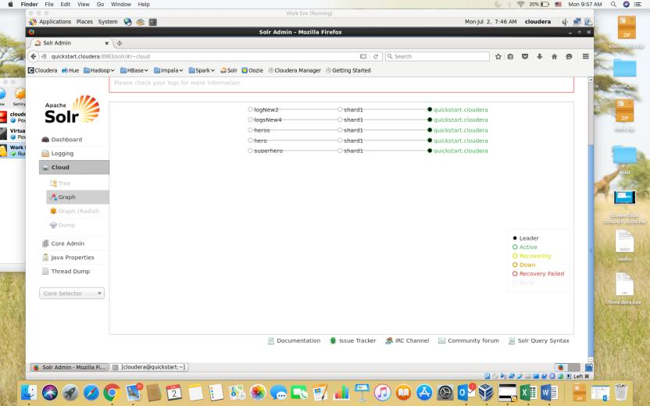

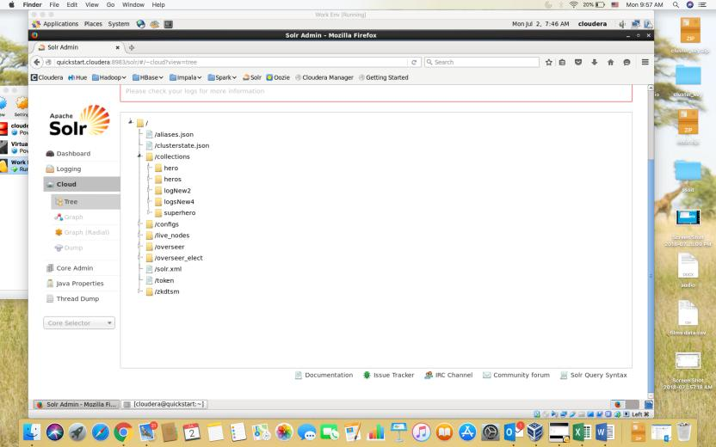

Step 2 – Loaded the superheros data in CSV format.

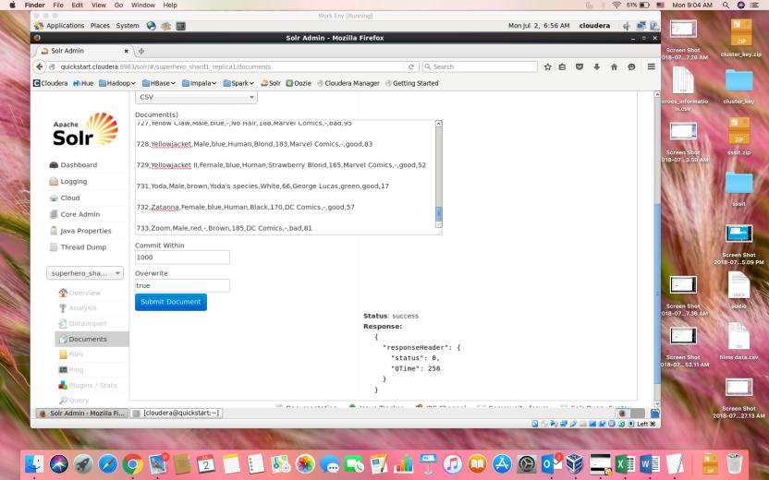

Step – 3 Performing basic query to retrive all data

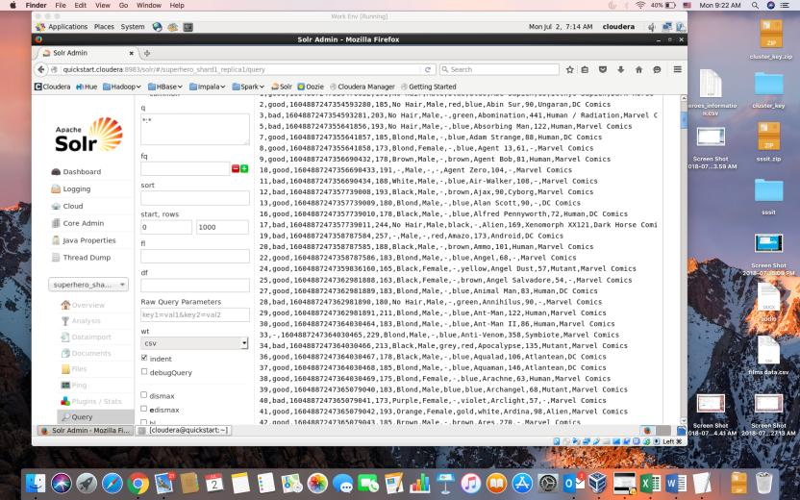

Step 4 – Different queries executed

Query 1 Filter all the male superhero characters

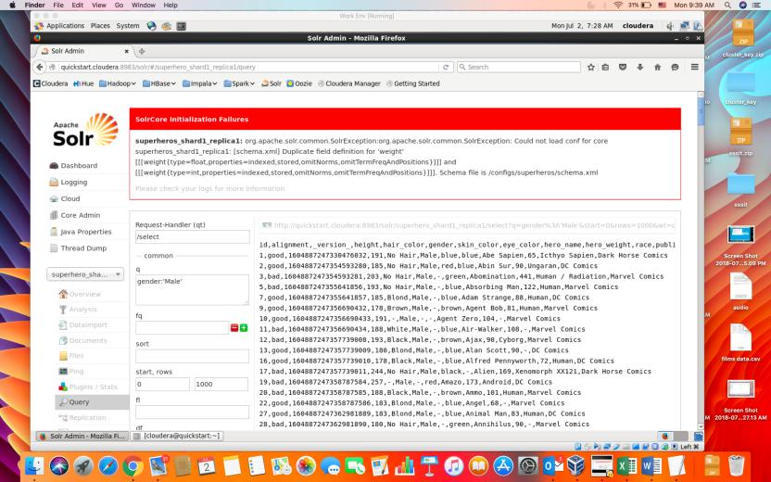

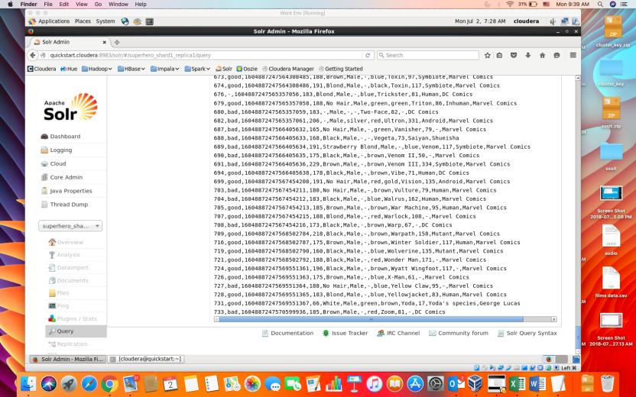

Query 2 – Filtering all the Female superhero characters

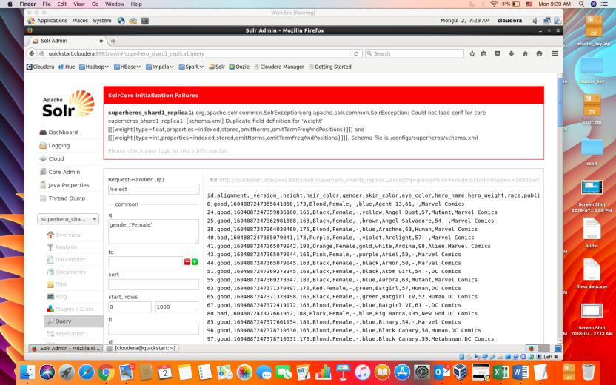

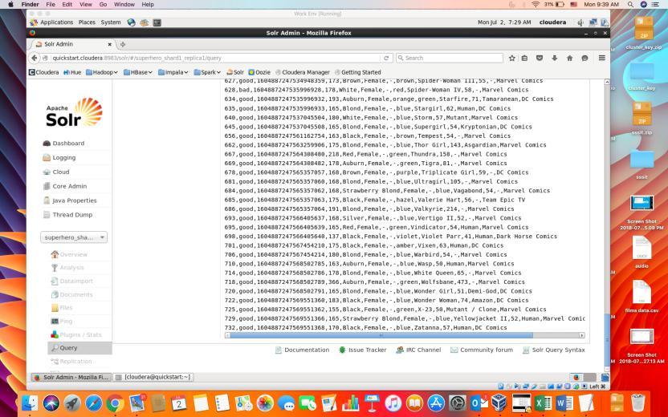

Query 3 – Filtering all Marvel Comics published characters

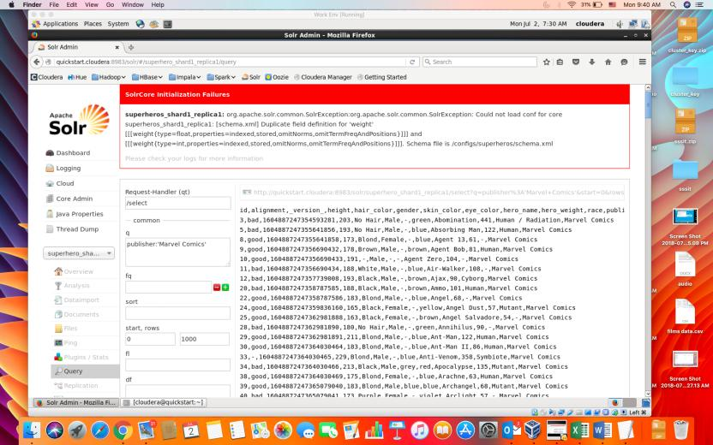

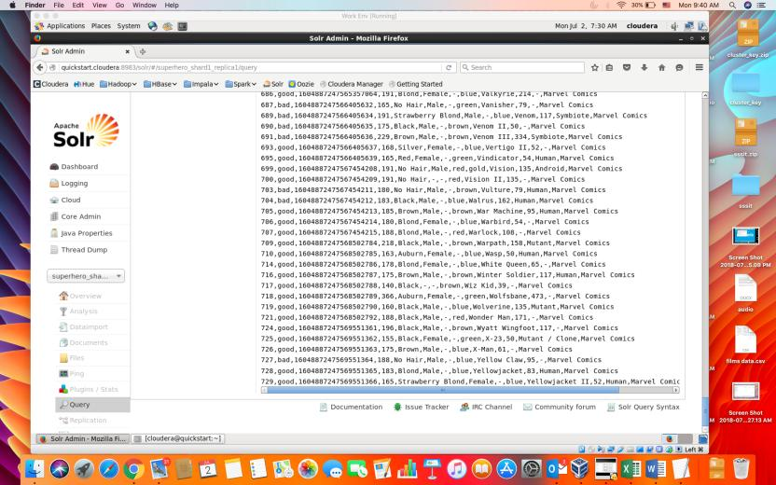

Query 4 – Filtering male superhero characters whose eye color is blue

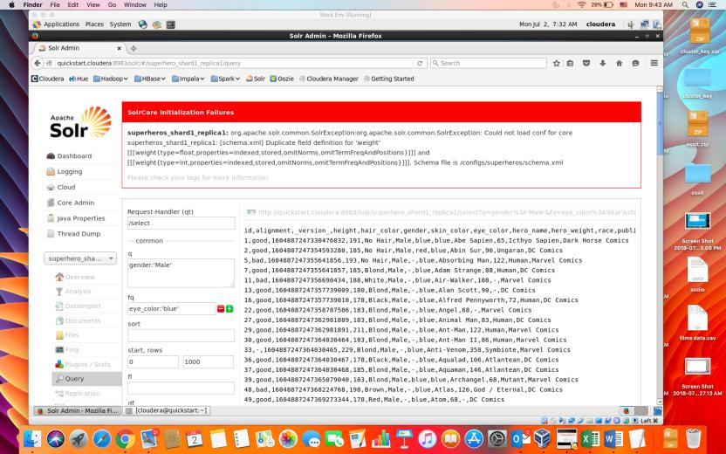

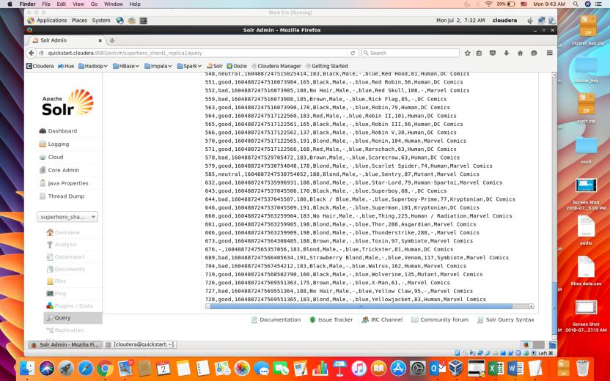

Query 5 - Filtering female superhero characters whose eye color is blue

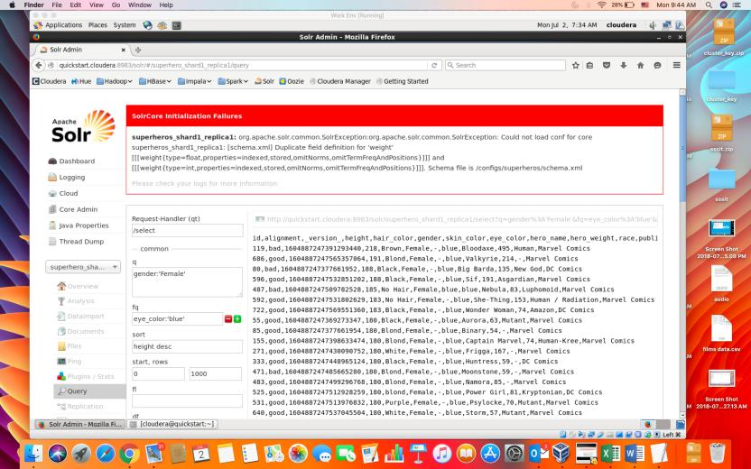

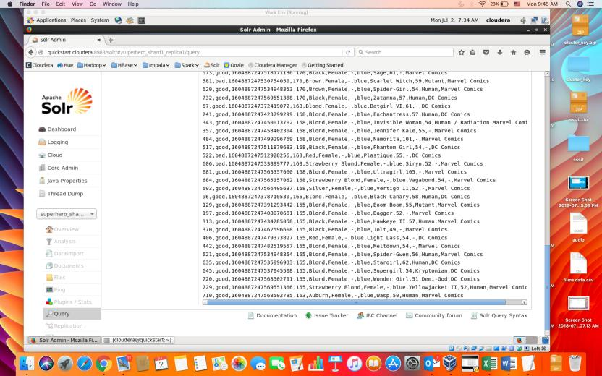

Query 6 – filter superhero characters whose height is between 200 to 300 cms and sort them with height descending.

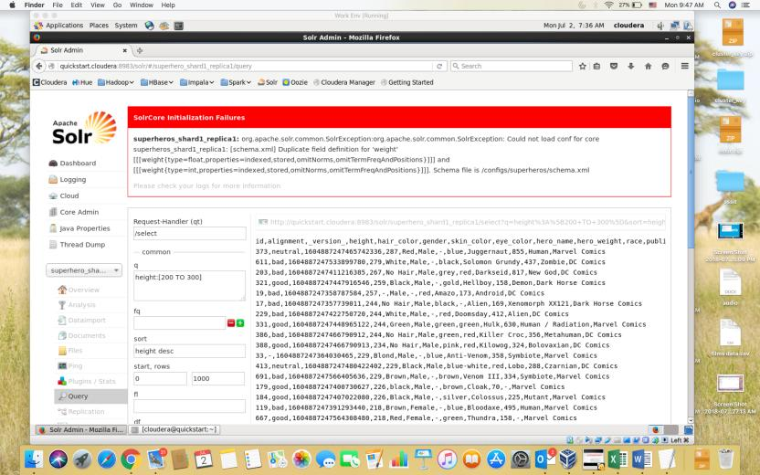

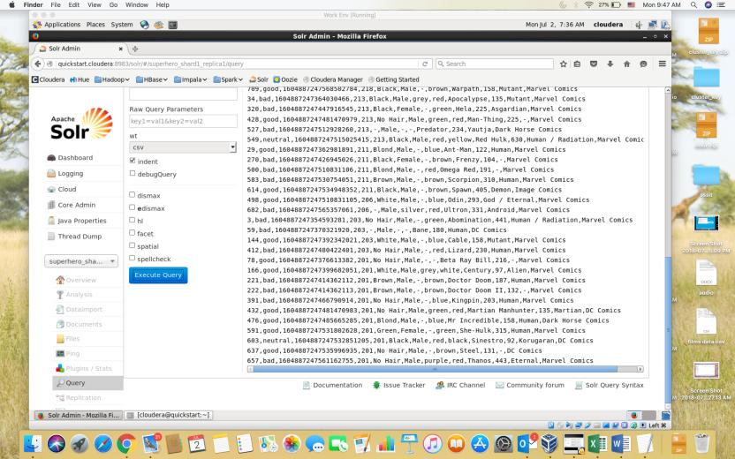

Query 7 – negative querying - filter superhero characters whose height is between 200 to 300 cms and sort them with height ascending

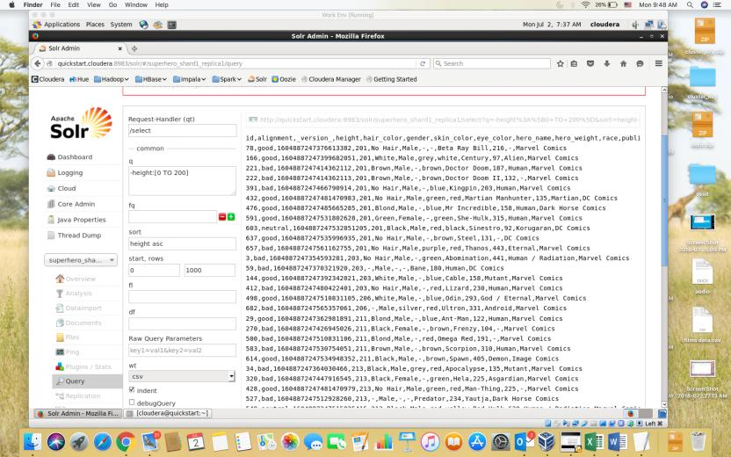

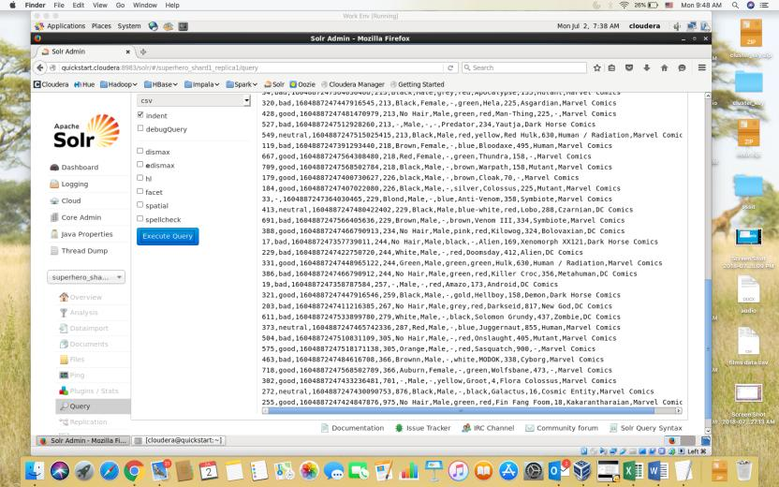

Query 8 – Fuzzy Search – race is human

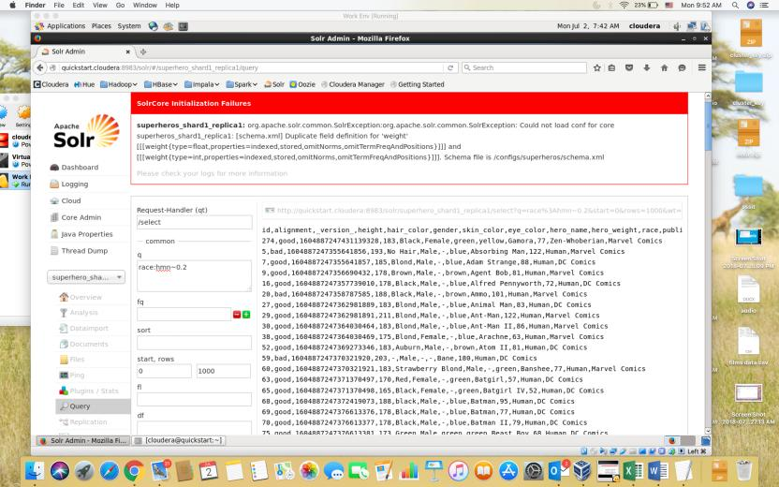

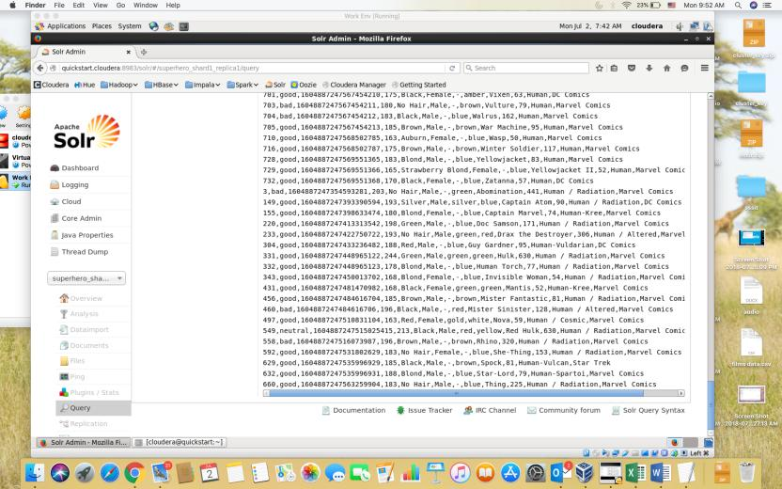

Query 9 – proximity search – returns all the rows that contain comics in its publisher name

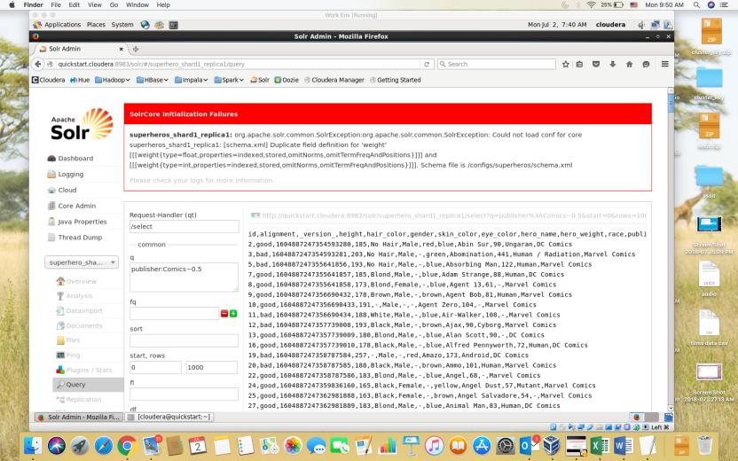

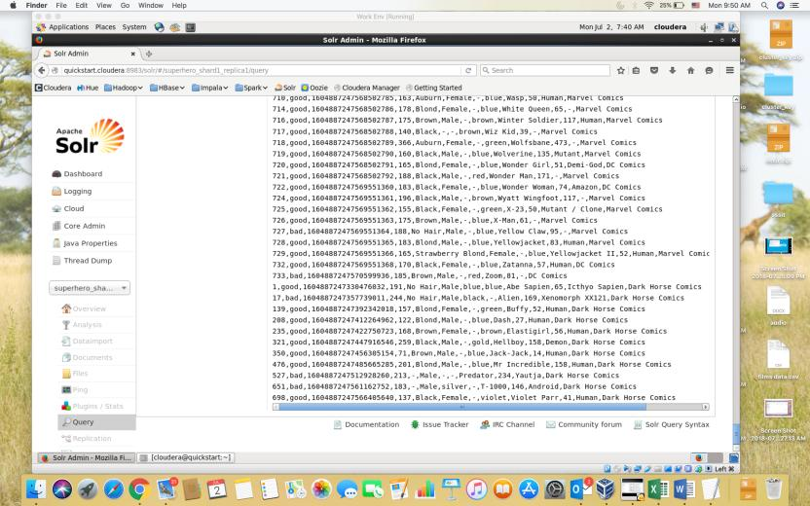

Query 10 – partial match

